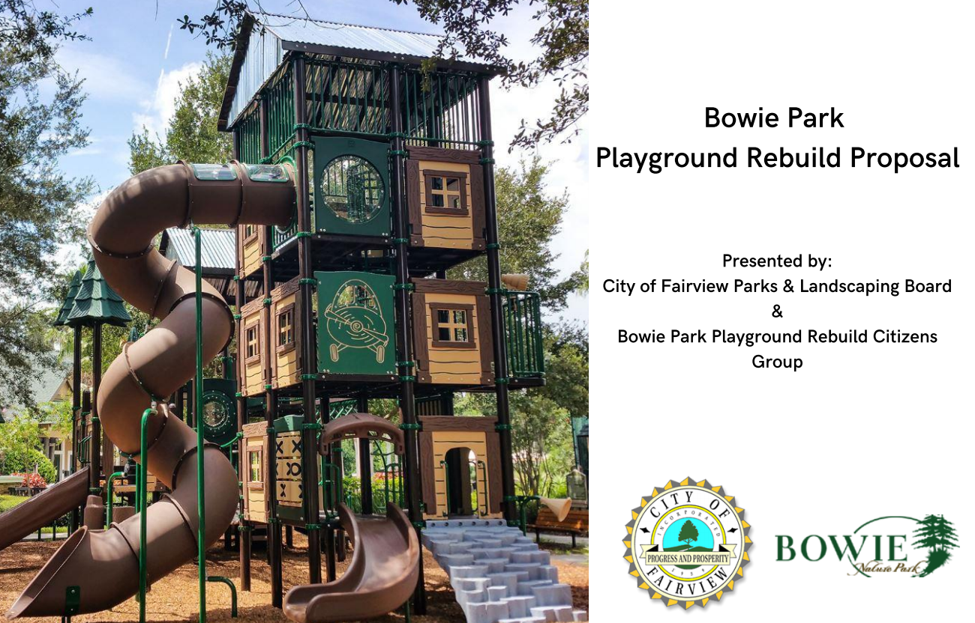

Contents
Executive Summary 3
Survey Results Summary 3
Equipment and Design Features 3
Maintenance Plan and Costs 3
Warranty Information 3
Phased Build Approach 3
Build Timeline 3
Pricing Quotes 3
Community Build Scenario – Construction Options 3
Fundraising Projections 3

Executive Summary

The Parks and Landscaping Board have worked with the Bowie Park Playground Rebuild Group (a citizens group) to explore and develop this proposal for a replacement playground at the City of Fairview’s Bowie Park.

We present this proposal to the BOC for their review, consideration, and feedback.

If the City were to choose to pursue this path, the Playground Rebuild Group would shift their focus to the fundraising phase of the project.

Actions Timeline

- July 6, 2019 – Treehouse playground removed due for safety concerns

- September 5, 2019 – BOC accepts proposal to allow the Parks and Landscaping Board to receive proposal from Bowie Park Playground Rebuild Group (a citizens group) for a replacement playground at Bowie Park in Fairview.

- August-September 2019 – Child Playground Survey (437 respondents)

- October 16, 2019 – First meeting of Bowie Park Playground Rebuild Group – vendor presentations

- August-October 2019 – Adult Playground Survey (820 respondents)

- November 6, 2019 – Vendor presentations

- November 16, 2019 – Playground tours (8 area playgrounds)

- December 11, 2019 – Vendor presentations

- January 18, 2020 – Playground Design Development Meeting and RFP crafting

- February 14, 2020 – RFP sent to 5 vendors

- March 16, 2020 – RPF responses collected

- Covid 19 – stalls meetings/progress

- May 21, 2020 -RPF review and follow-up questions meeting

- June 16, 2020 – Vendor refinement – zoom Meeting

- June 17, 2020 – Vendor refinement – zoom Meeting

- July 19, 2020 – Proposal development – zoom Meeting

- August 13, 2020 – Proposal refinement – zoom meeting

- August 19, 2020 – Parks and Landscaping Board Meeting – review/approve to present to BOC

- August 20, 2020 – P&L Proposal presentation to BOC

Survey Results Summary

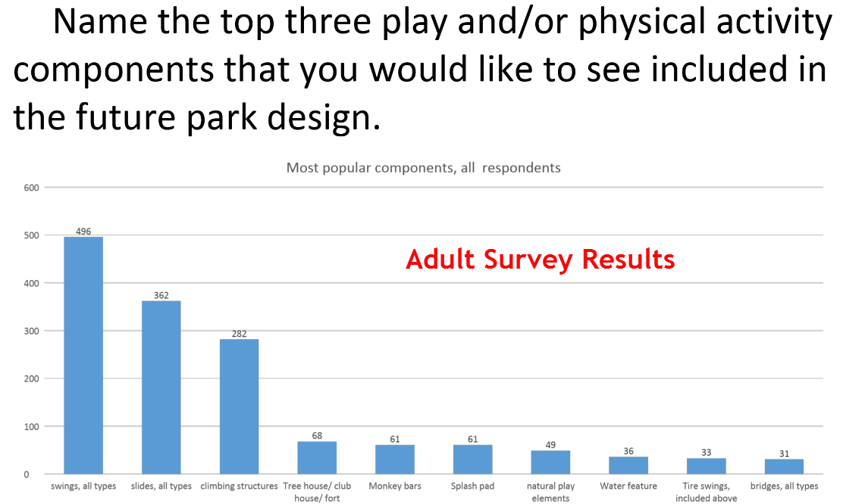
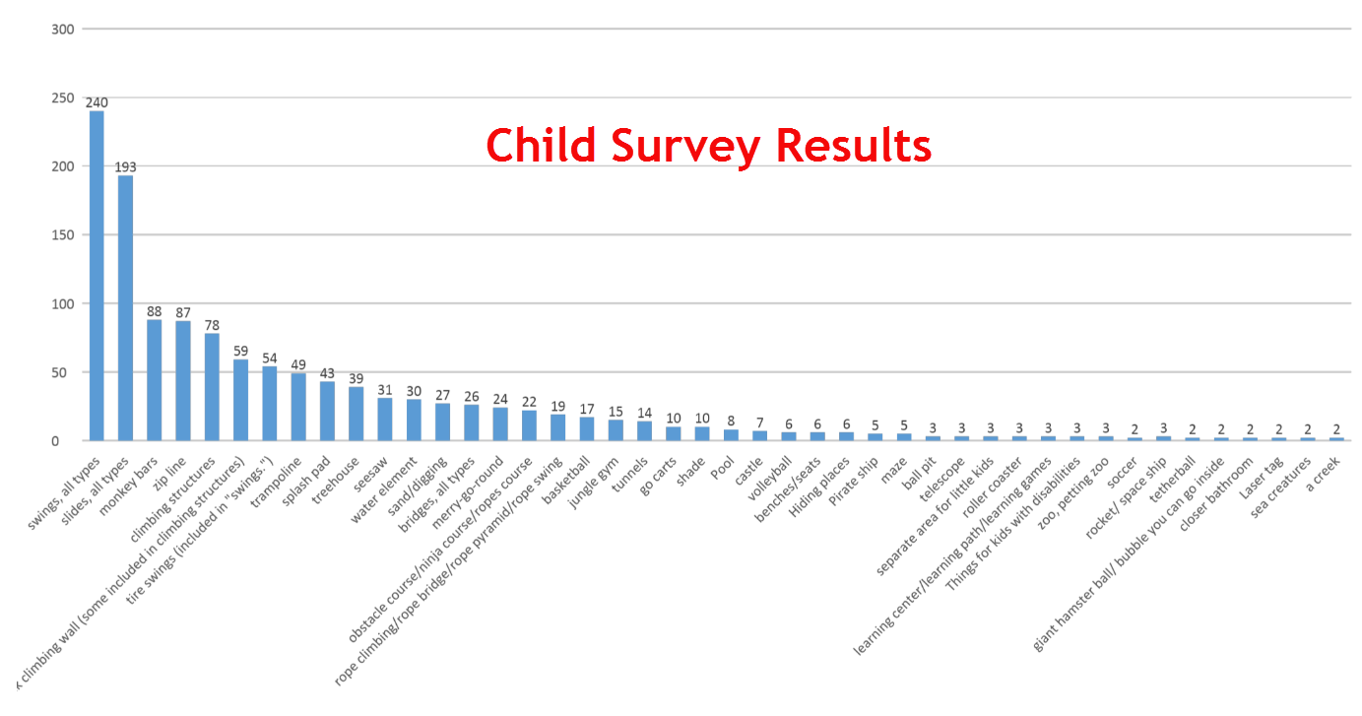

Equipment and Design Features
Design Renderings/Equipment Info/Design ADA Compliance

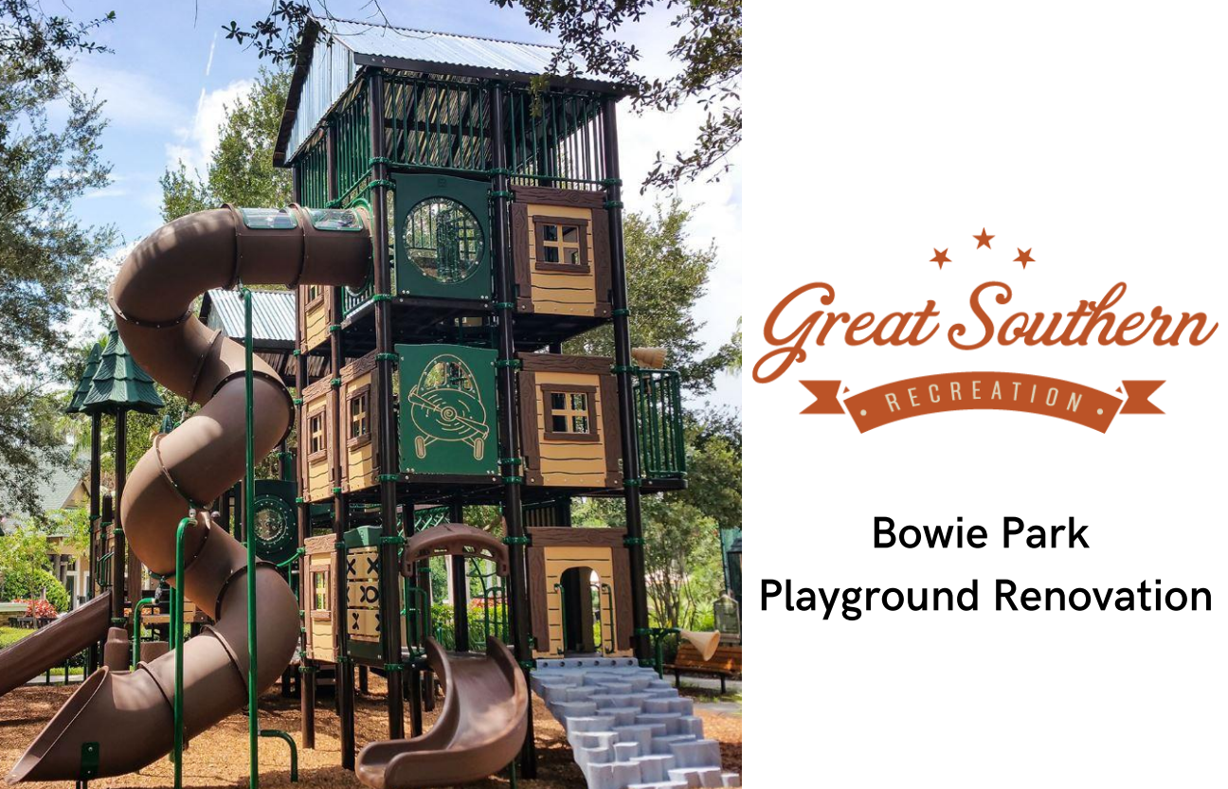
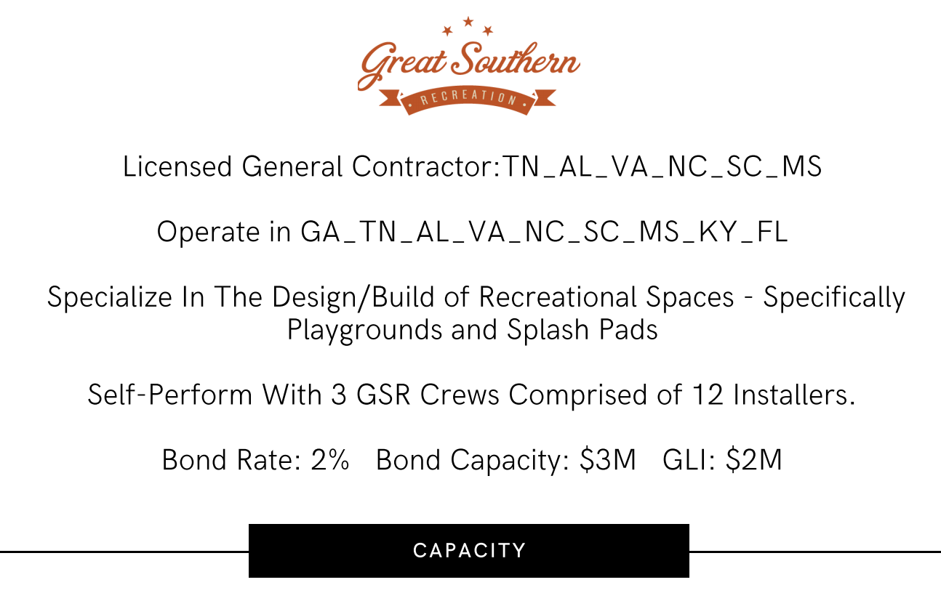
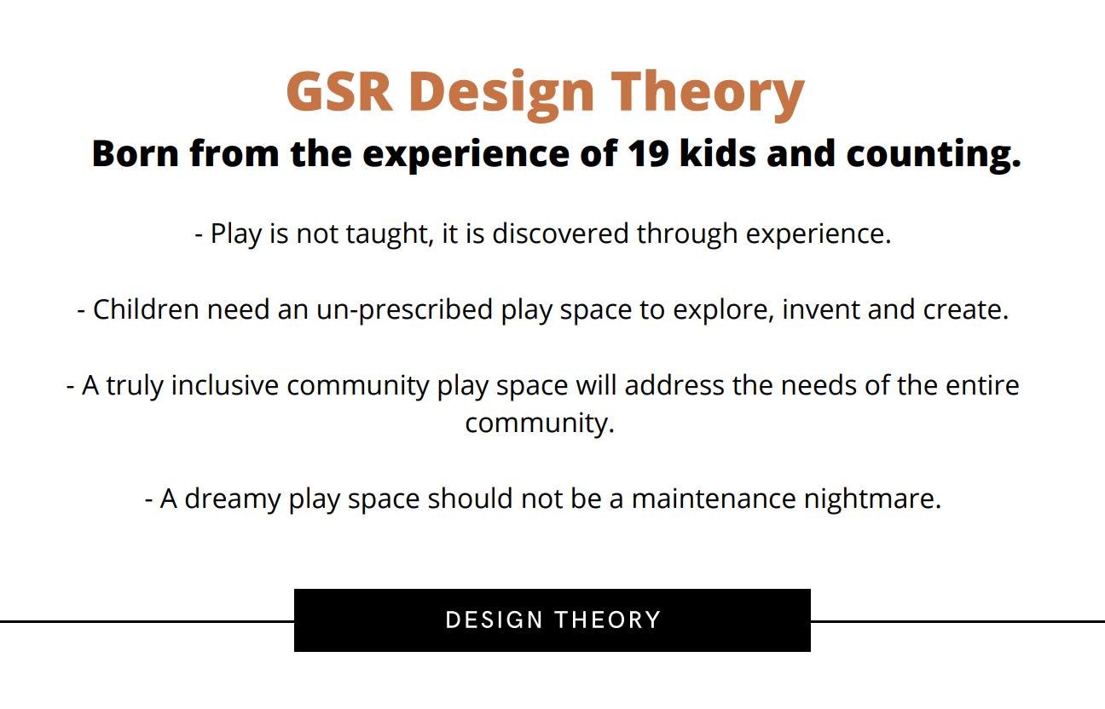
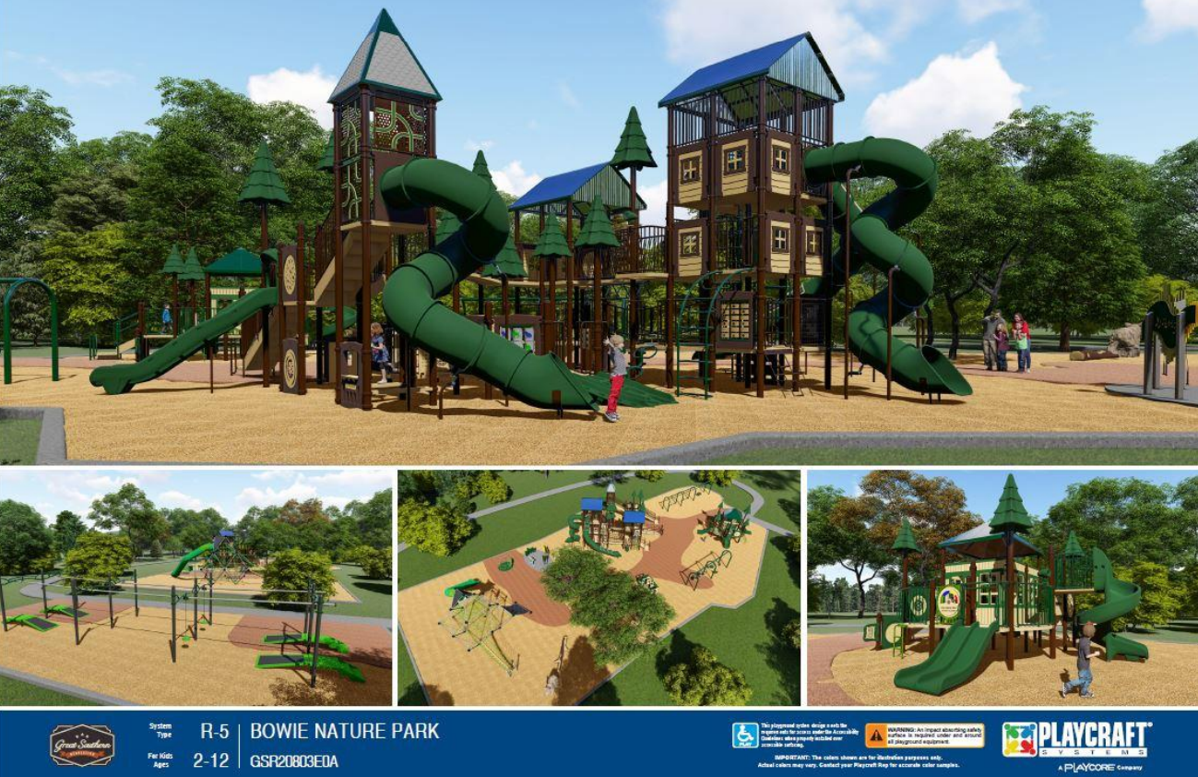

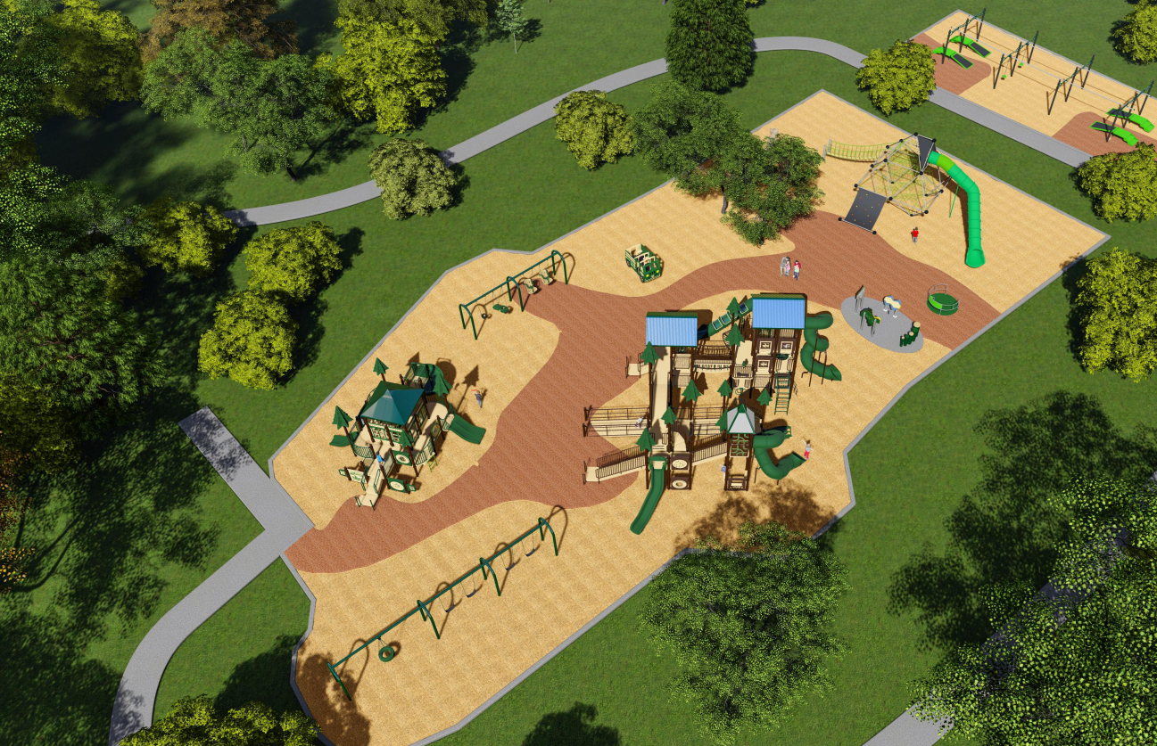

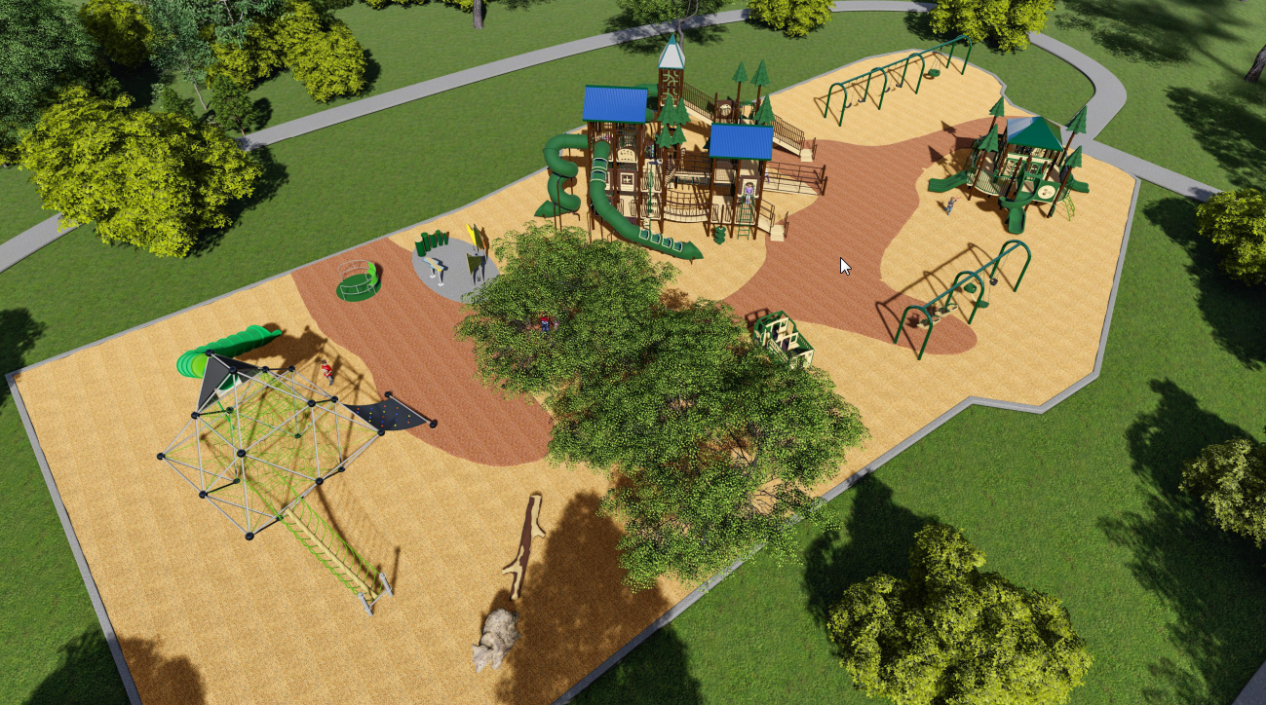

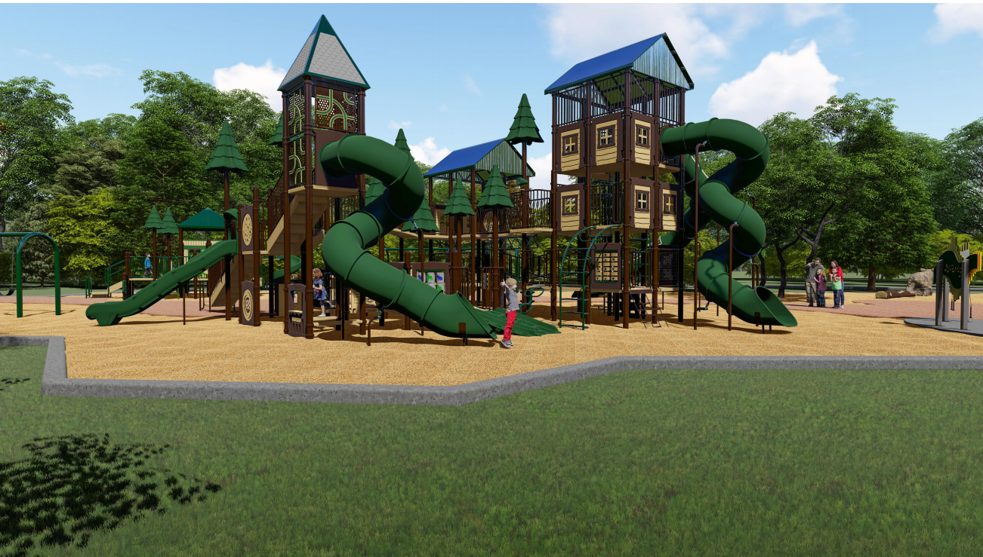
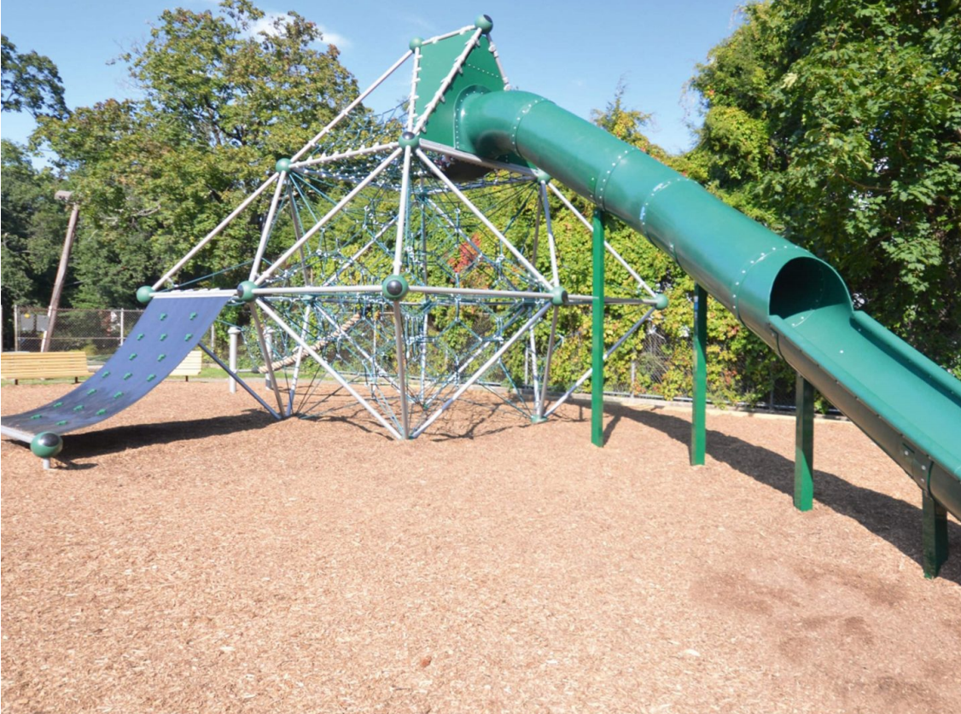
Berliner Neptun.20 Climber

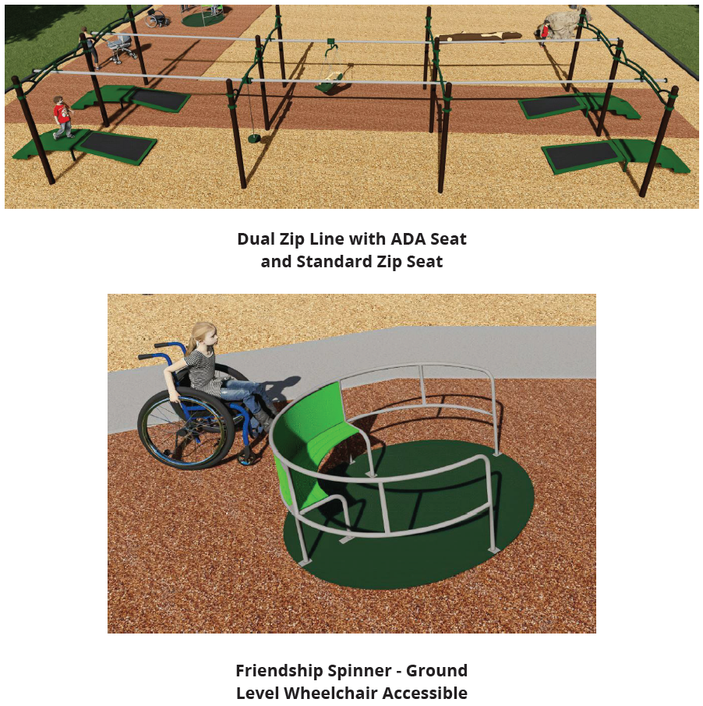

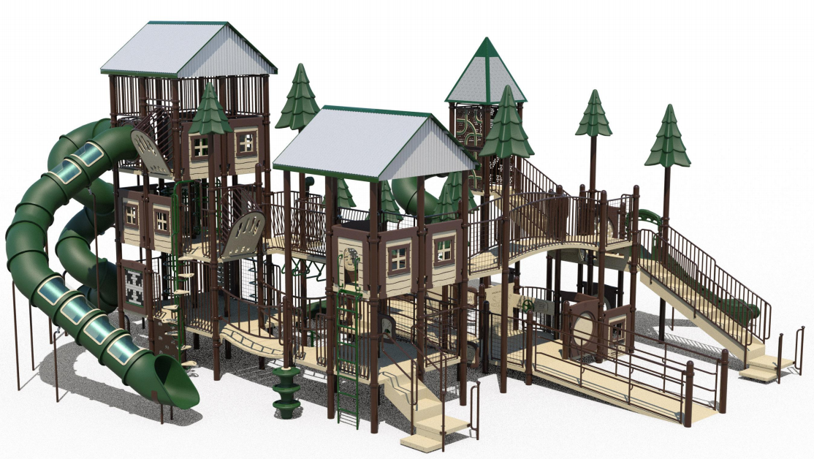
5 to 12 year old Ramped Treehouse Structure

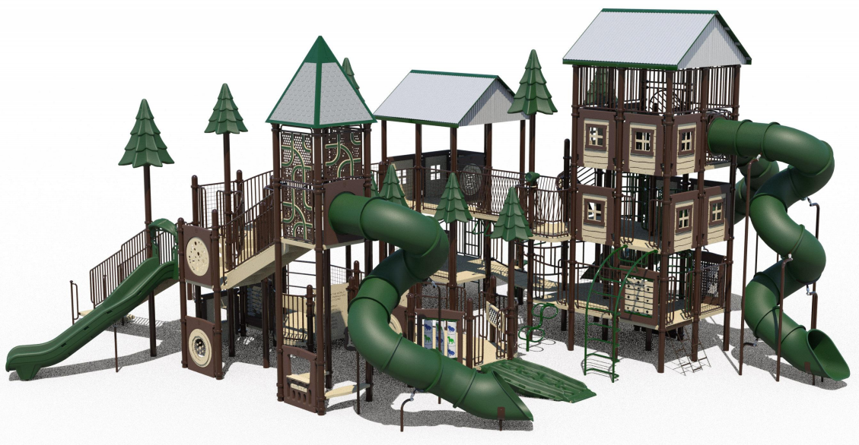

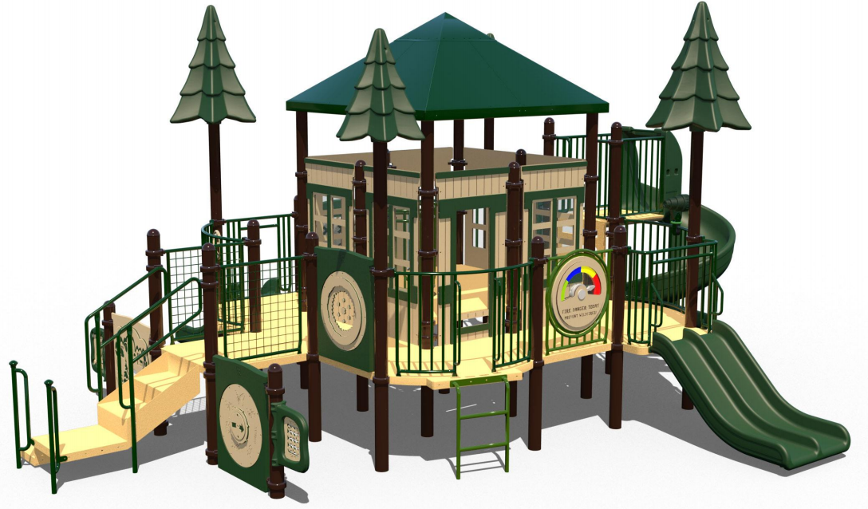
2 to 5 year old Treehouse Structure

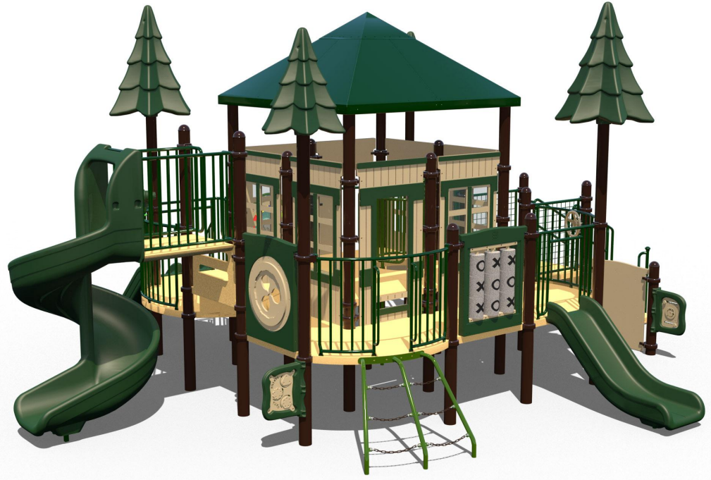

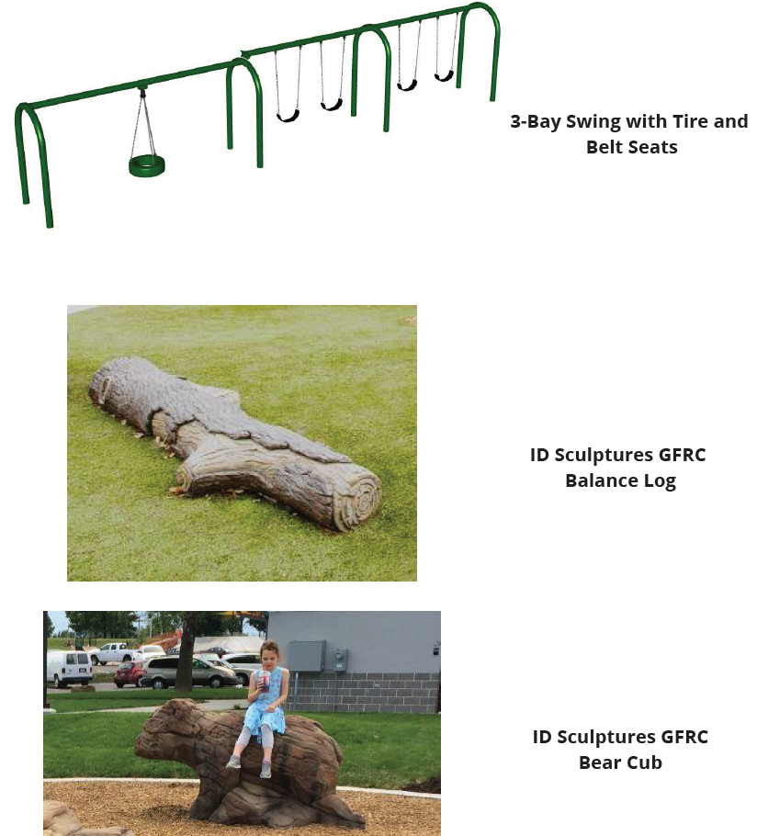
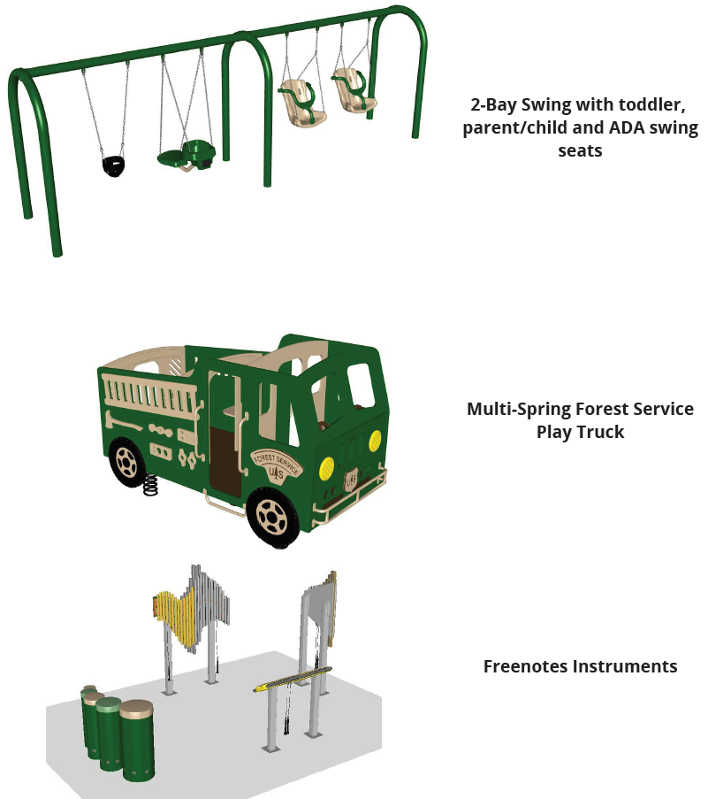

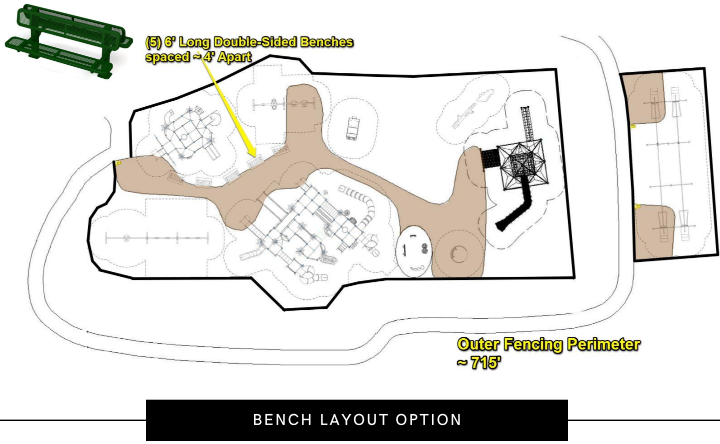

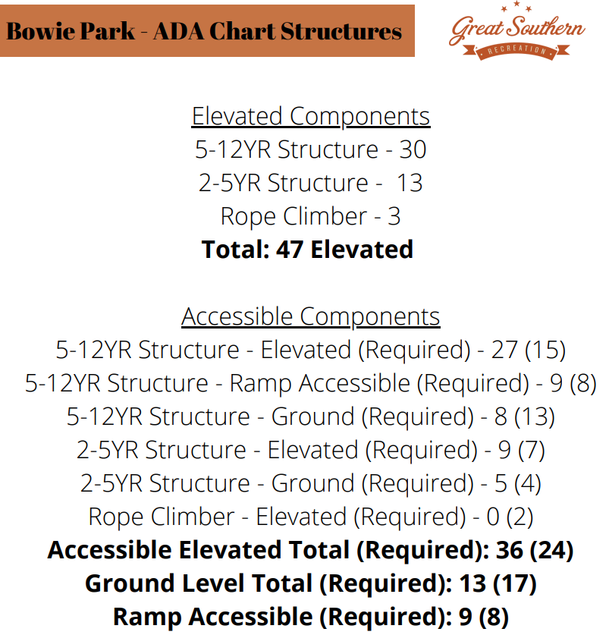

Maintenance Plan and Costs

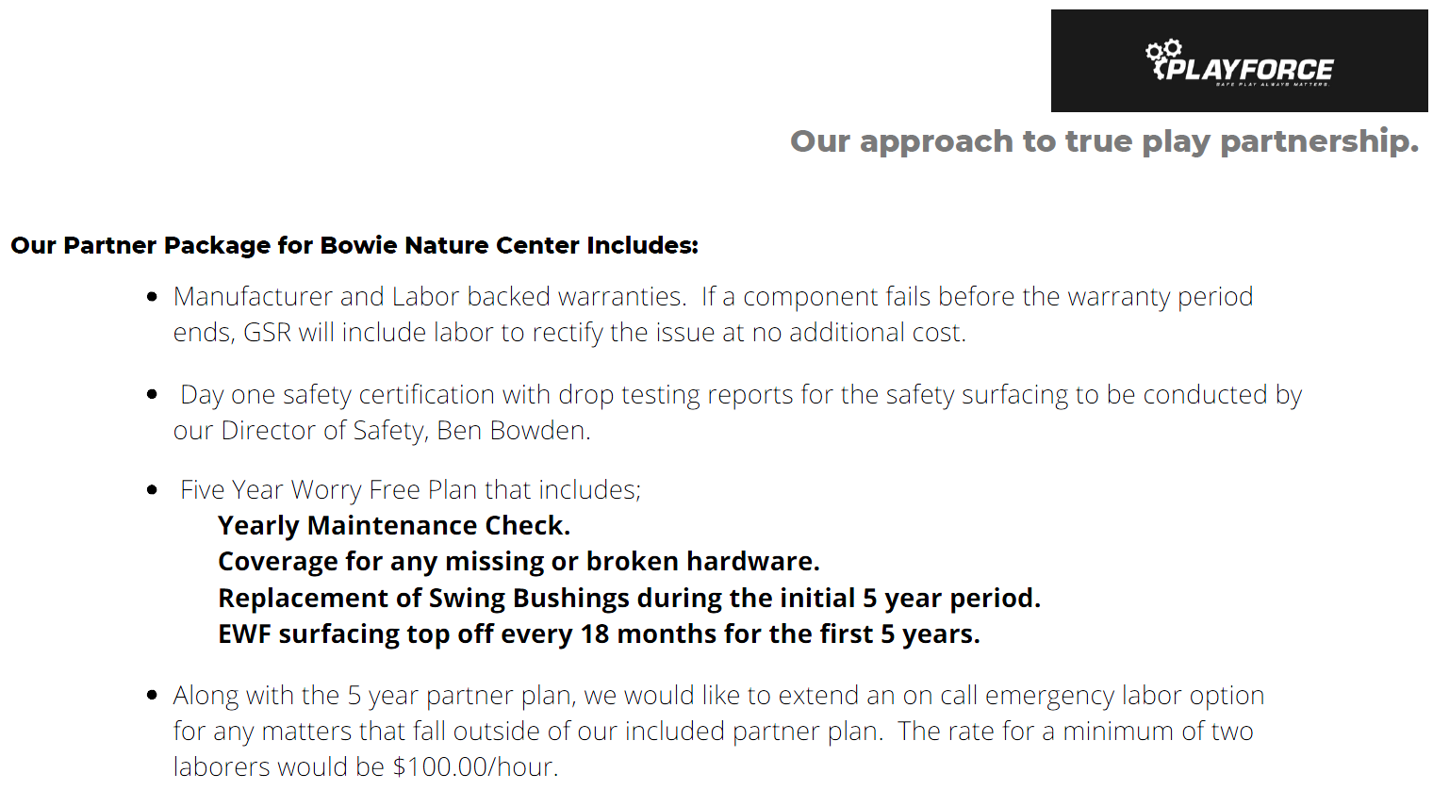
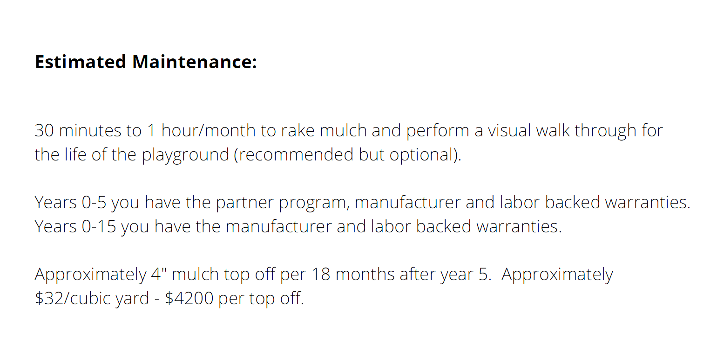

Warranty Information
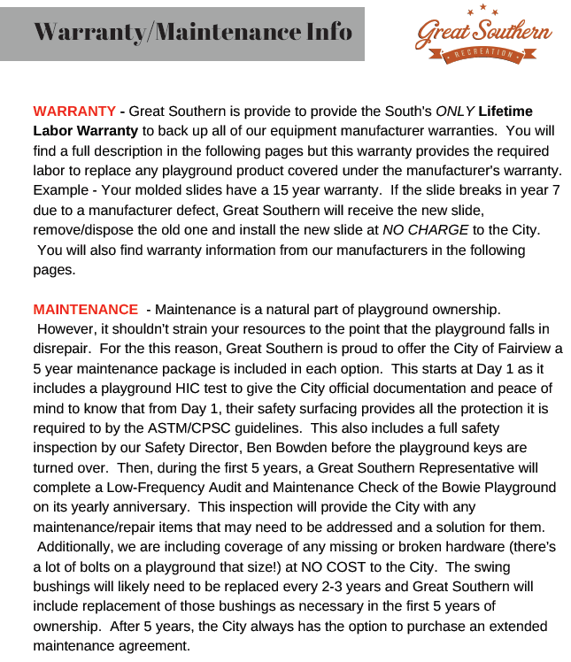

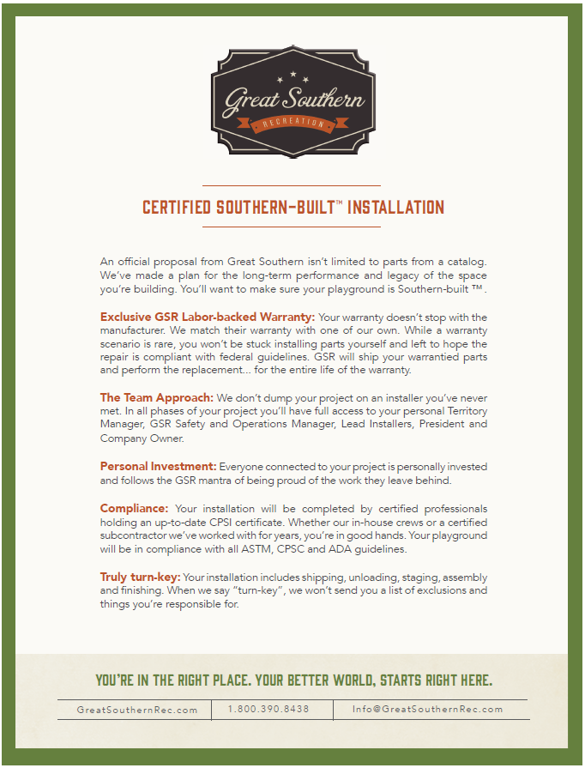

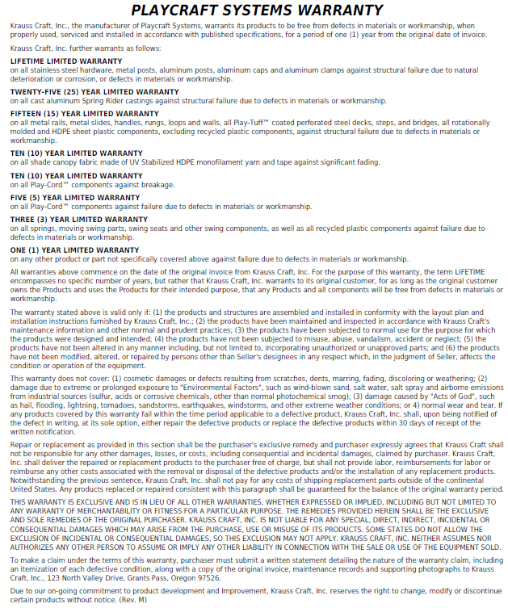

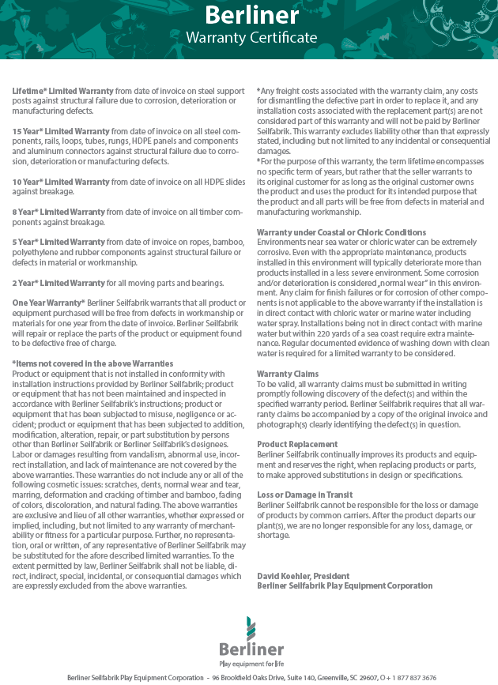

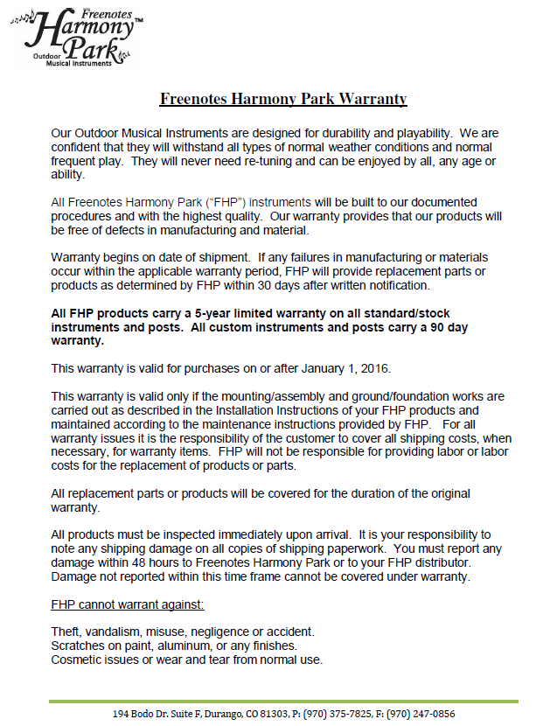

Phased Build Approach

Phase 1
- 5-12YR Treehouse Structure
- 2-5YR Treehouse Structure
- 5-12YR 3-bay swing
- 2-5YR 2-bay swing (ADA Seat swing area)
- 3 of the 6 park benches to be used as perimeter seating
- Wood Mulch
- Bonded Rubber
- Borders

Phase 2
- Rope Climber
- Remaining 3 of 6 benches used as perimeter seating
- Wood Mulch
- Bonded Rubber
- Borders

Phase 3
- 2-12YR Multi-Spring Rider
- Freenotes Music Instrument Area
- Friendship Spinner
- GFRC Bear and Balance Log

Phase 4
- Double Zip Line
- Wood Mulch
- Bonded Rubber
- Borders

Build Timeline

Full Build – Entire Turnkey Design

12-14 weeks from time of order

Berliner net climber has a longer lead time (an additional 2-4 weeks) but we would normally begin installation on the rest of the equipment and install the rope climber when it arrives.

- Installation time about 4 weeks with decent weather could extend to 6 weeks if weather delay
- Play equipment layout and installation - 2-4 weeks
- Border/Perimeter construction and rubber surfacing substrate - 1 week
- Rubber Surfacing and wood mulch installation - 1 week

Phased Build Timeline

Phase 1
10-12 weeks - similar to the turn-key install layout above, with a 1-2 week reduction off the full timeline above (minus 2-4 weeks for the rope climber)

Phase 2
14-16 weeks - production/delivery for the rope climber. 2-3 weeks installation total (1 week for rope install, 1 week for additional surfacing and an extra week for weather)

Phase 3
10-12 weeks - equipment production/delivery and 2-3 weeks installation

Phase 4
8-10 weeks - equipment production/delivery and 2 weeks installation

Pricing Quotes

Pricing subject to 7% annual increase (estimated annual price increase from manufactures)
Full Build Turnkey - $640.281.75

Partial Community Build - $625,639.25

Full Community Build - $520,464.35

Phased Turnkey Build

Phase 1 - $400k
- 5-12YR Treehouse Structure - $249,852
- 2-5YR Treehouse Structure - $81,606
- 5-12YR 3-bay swing - $12,157
- 2-5YR 2-bay swing (ADA Seat swing area) - $12,187
- 3 of the 6 park benches to be used as perimeter seating - $2,645
- Wood Mulch (327 yards) - $14,511
- Bonded Rubber - $27,263
- Borders - $8,190

Phase 2 - $106k
- Rope Climber - $89,496
- Remaining 3 of 6 benches used as perimeter seating - $2,645
- Wood Mulch (44 yards) - $2,168
- Bonded Rubber - $11,656
- Borders - $2,730

Phase 3 - $87k
- 2-12YR Multi-Spring Rider - $11,510
- Freenotes Music Instrument Area - $31,446
- Friendship Spinner - $24,520
- GFRC Bear and Balance Log - $21,752

Phase 4 - $51k
- Double Zip Line - $36,149
- Wood Mulch (75 yards) - $3,253
- Bonded Rubber - $9,471
- Borders - $2,730

Fencing (wood fence) estimated at $39k….still researching non-wood options

Full Build Turnkey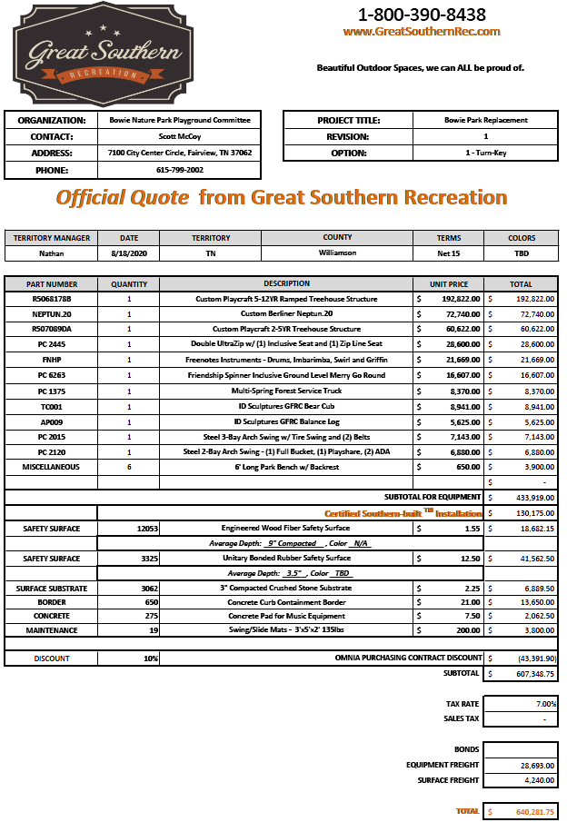
Partial Community Build
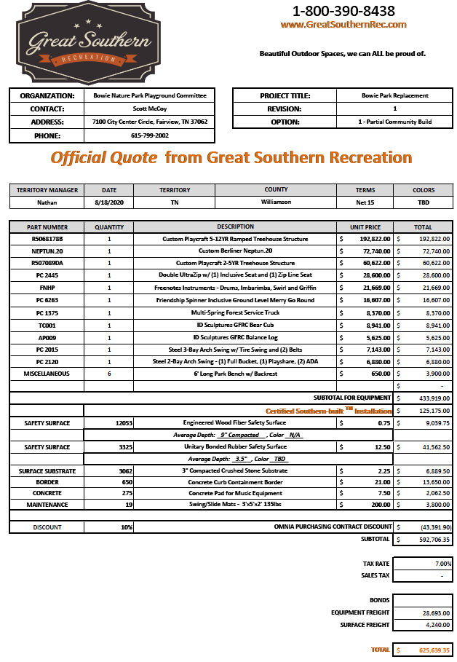
Full Community Build
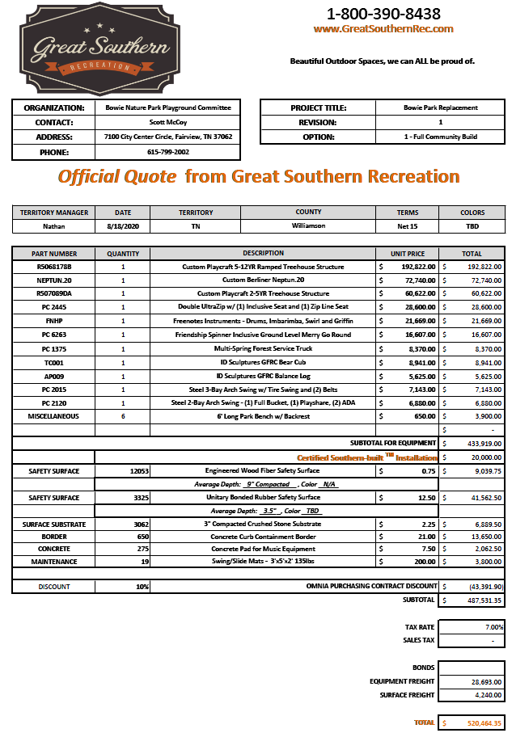

Community Build Scenario – Construction Options

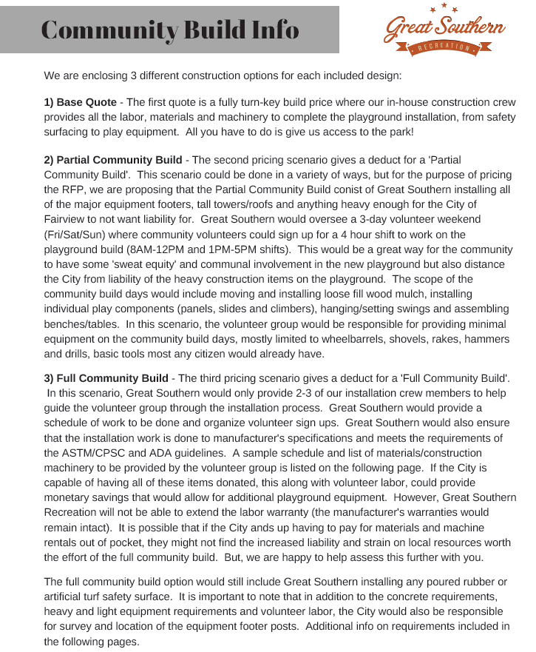

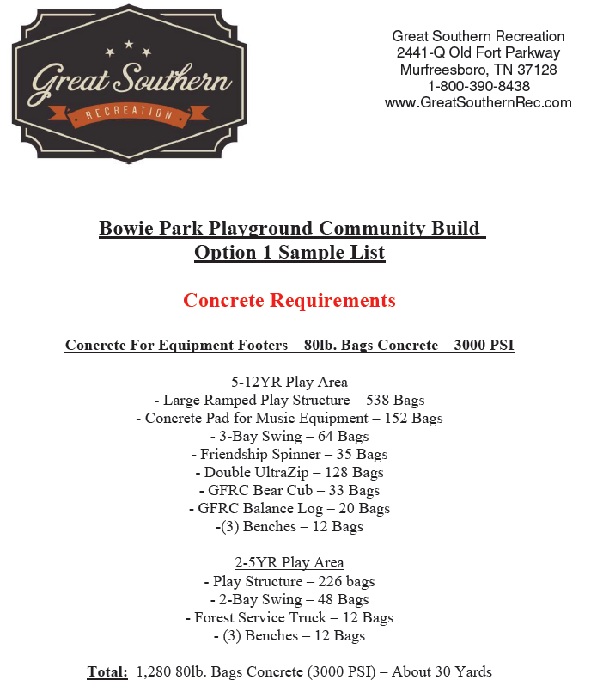

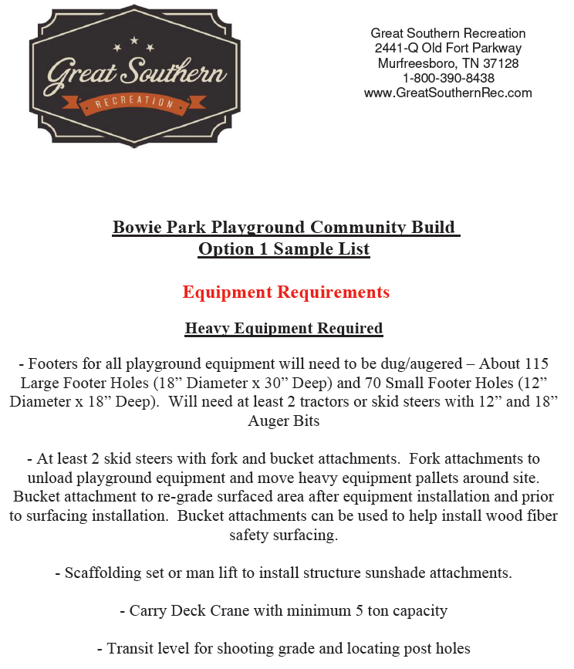

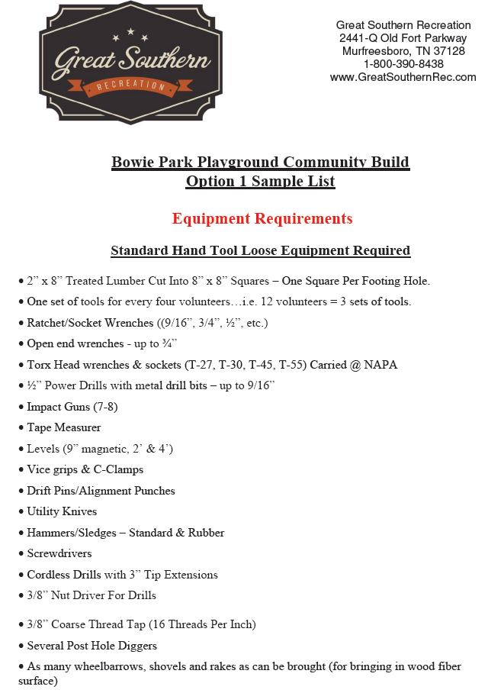

Fundraising Projections

Current Community Fundraising Balance: $21,220.23

With Covid-19 restrictions and conditions, fundraising projections are subject to greater uncertainties:

- Limitations on gatherings and events (BBQ event, car shows, car washes, etc.)
- Potentially less funding available from corporate sponsors (slowdown in revenue and increased expenses)
- Potentially less funding available from individual donors (negative discretionary income impacts)

That said the Playground Build Group believes we can raise funds according to the estimate schedule below:

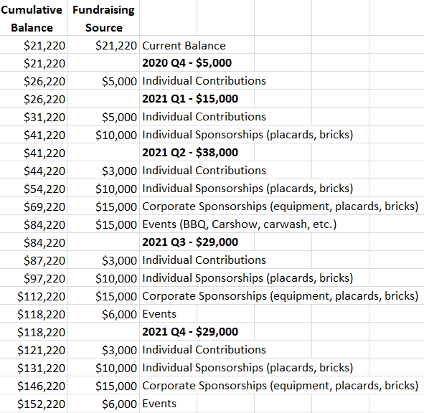

Note that we will explore funding in grants – we can begin the process of review, qualification, eligibility, and application with a final approved design. We also believe we may find some material donations or discounts on materials such as mulch.

